**DBMS Assignment – 2**

**MIS – 642303019 DIV – 2 ; Batch – T5**

**Name – Deepak Zumbar Shitole**

### Aggregates and grouping and ordering.

Q) **Find the number of instructors who have never taught any course**.

Ans)

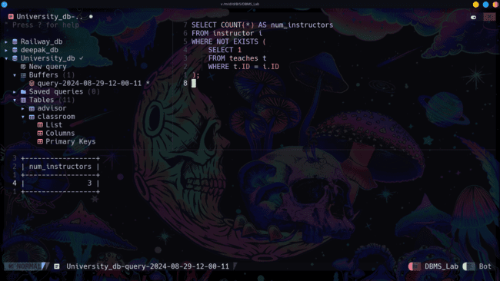**Q)**

**Find the total capacity of every building in the university**

Ans)

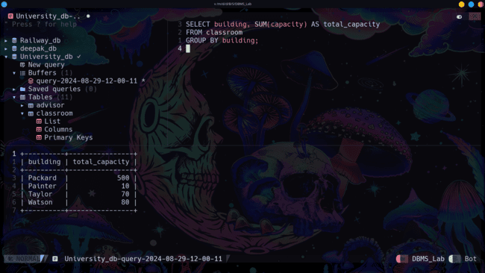

Q**) Find all departments that have at least one instructor, and list the names of the departments along with the number of instructors; order the result in descending order of number of instructors.**

Ans)

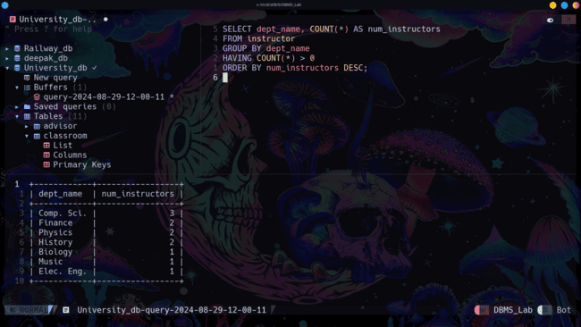

Q) **For each student, compute the total credits they have successfully completed, i.e. total credits of courses they have taken, for which they have a non-null grade other than 'F'. Do NOT use the tot_creids attribute of student.**

Ans)

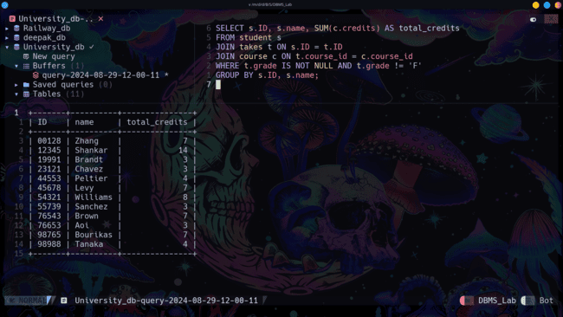

**B.Nested Subqueries**

**Q) Find the id and title of all courses which do not require any prerequisites.**

**Ans)**

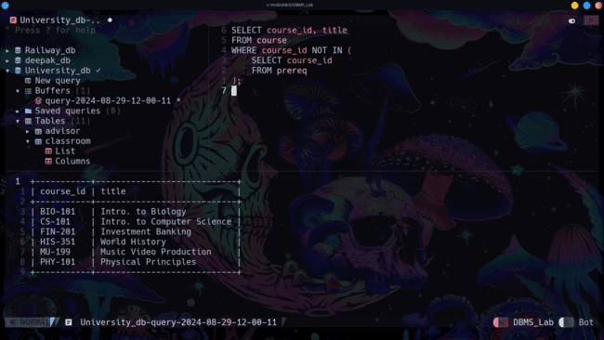

**Q) Find the names of students who have not taken any biology dept. courses**

Ans)

